**Assignment 5 Bezier surface**

My code was referenced and built on top of our Bezier surface tutorial. The only difference from our homework was that instead of having 4 x 4 they asked for a 5 X5 from us. So, in order to achieve that I had to create 25 control points as shown below:

**1) Use 25 (5 x 5) control points**

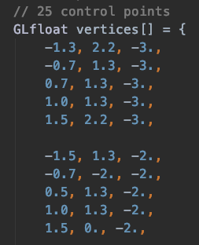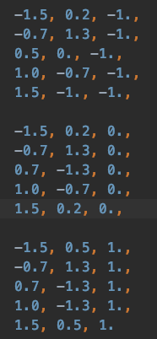

**2) Use TCS to set subdivision level**

I had to specify I had 25 vertices in the TCS file

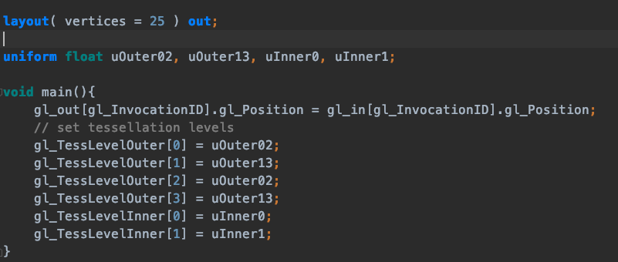

**3) Use TES to calculate new vertex coordinates and texture coordinates according to the mathematical equation of Bezier surface**

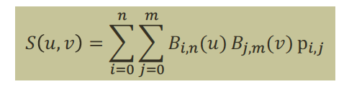

**(From the tutorial)**

For a 5x 5, I had to follow the formula and so I had to add p43, p04, p14, p24, p34, p44, bu4,bv4

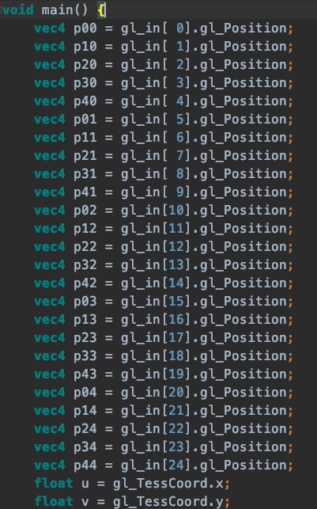

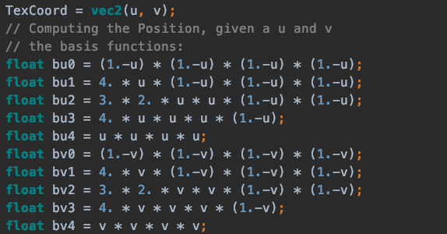The final computation is as follows in the program:

gl_Position = bu0 * ( bv0*p00 + bv1*p01 + bv2*p02 + bv3*p03 + bv4*p04 ) + bu1 * ( bv0*p10 + bv1*p11 + bv2*p12 + bv3*p13 + bv4*p14 ) + bu2 * ( bv0*p20 + bv1*p21 + bv2*p22 + bv3*p23 + bv4*p24 ) + bu3 * ( bv0*p30 + bv1*p31 + bv2*p32 + bv3*p33 + bv4*p34 ) + bu4 * ( bv0*p40 + bv1*p41 + bv2*p42 + bv3*p43 + bv4*p44 );

4) Change smoothness of the surface by keyboard

Use X AND Z key to change

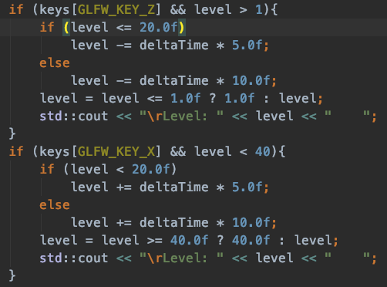

5) Support wireframe mode display.

Use the key C to change modes.

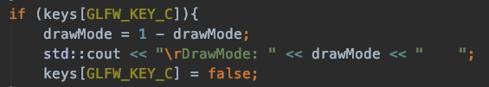

This triggers the GL_FILL and GL_LINE when KEY C is pressed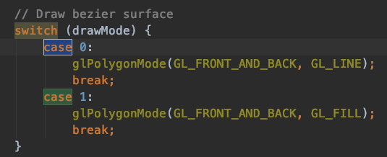

6) Add texture to Bezier surface. Choose the texture by yourself.

The textures are drawn by the shader files.

Final result:

